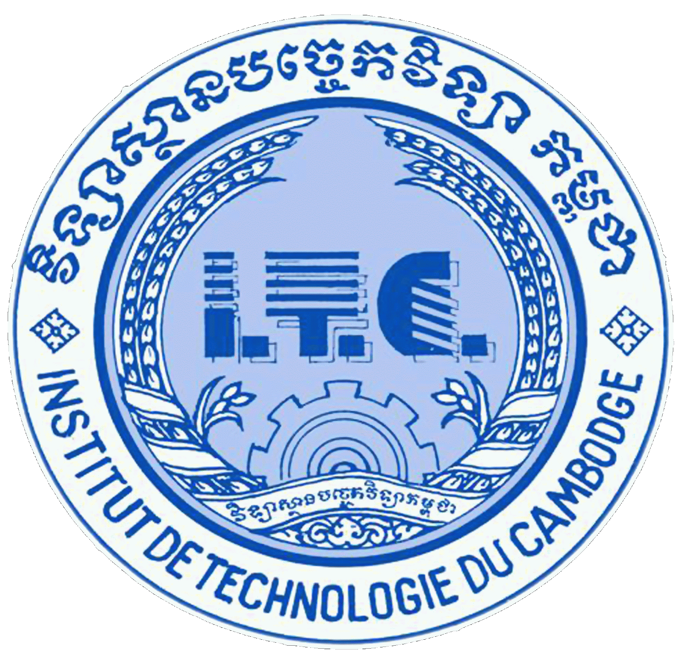 

INSTITUT DE TECHNOLOGIE DU CAMBODGE

***ASSIGNMENT TP4***

***ALGORITHM AND PROGRAMMING***

***LECTURER: BOU CHANNA***

***STUDENT’S NAME:*** *YIN SOKNARA*

***ID:*** *e20191298*

***GROUP:*** *I3-GIC(C)*

*YEAR 2021-2022*

Contents

Ex1: 3

Ex2: 4

Ex3: 5

Ex4: 6

Ex5: 7

# Ex1:

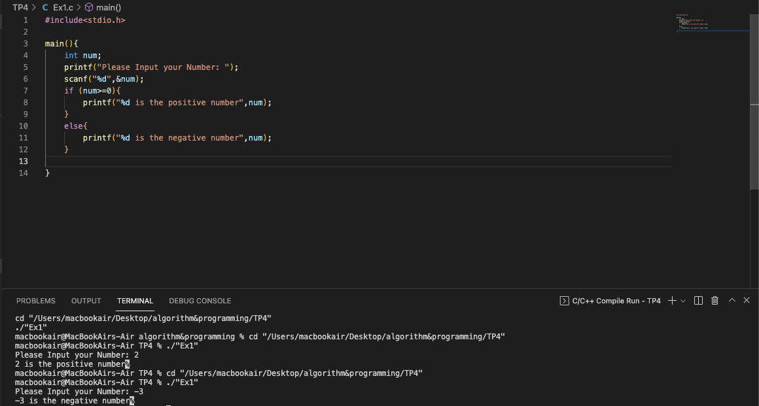

# Ex2:

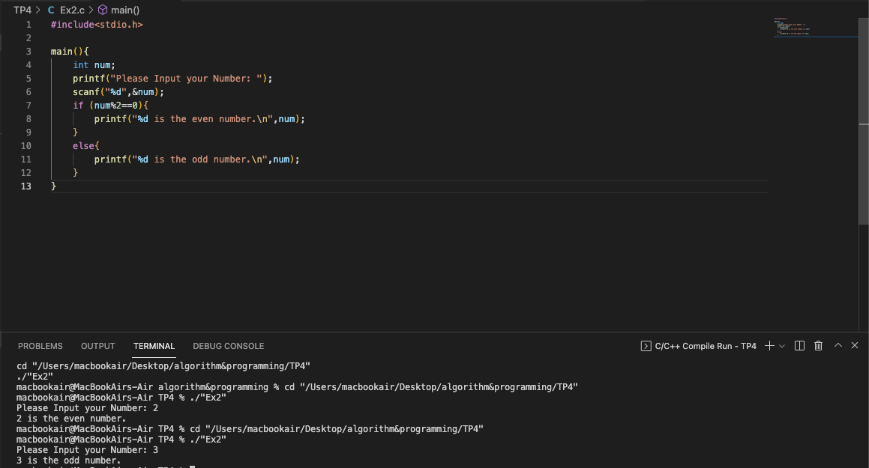

# Ex3:

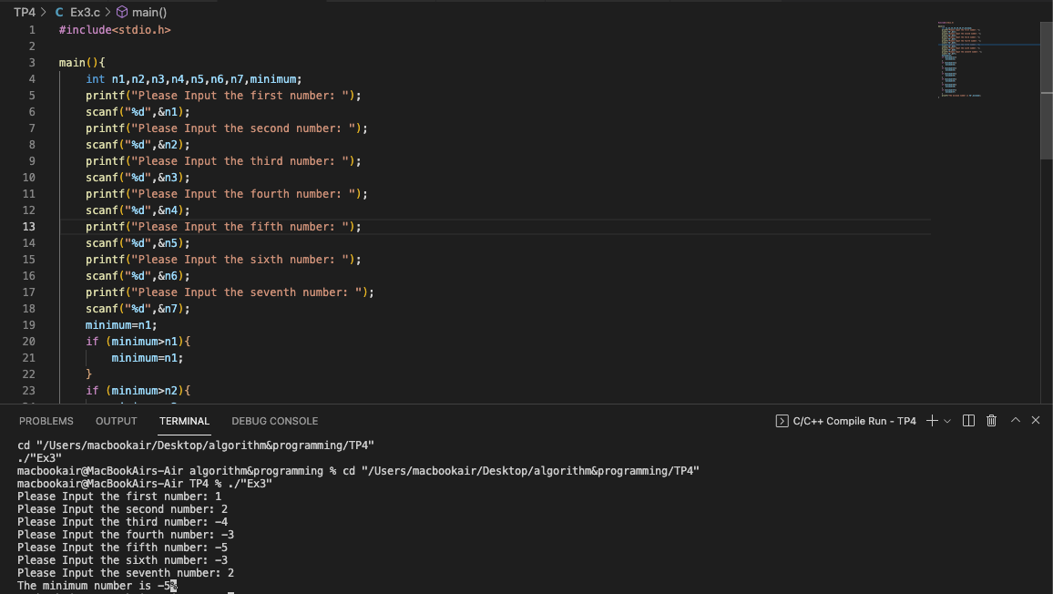

# Ex4:

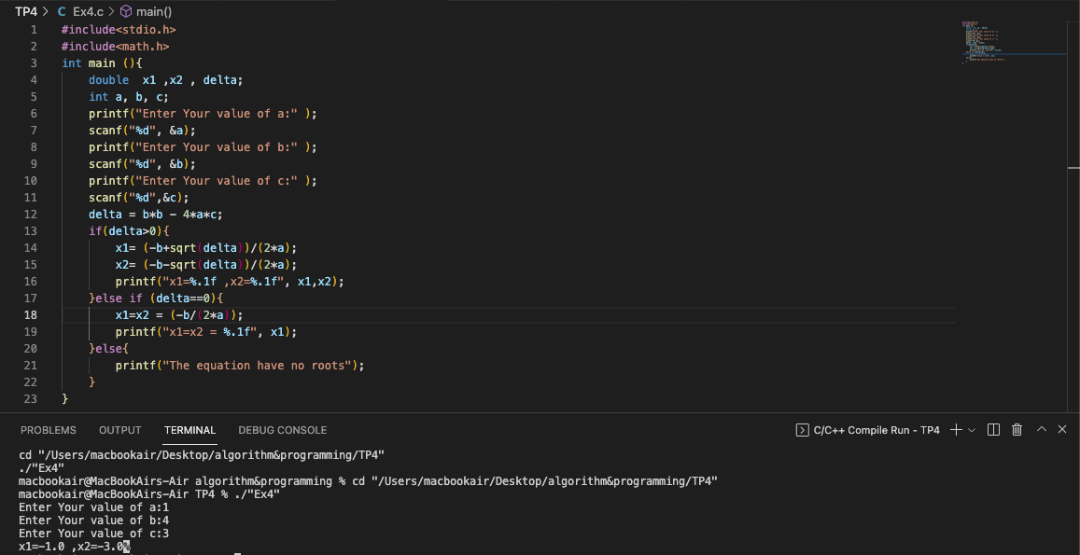

# Ex5:

